Chapter 3, Solution 19

At node 1,

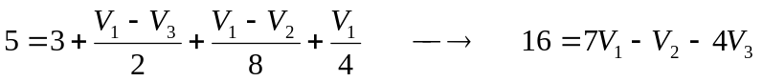 (1)
At node 2,

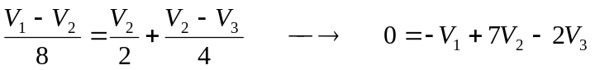 (2)
At node 3,

(3)
From (1) to (3),

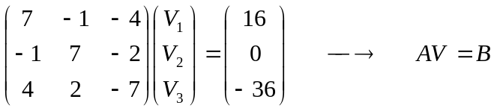
Using MATLAB,

